# Motors : 1- Micro Servo Motor (1.3kg.cm)

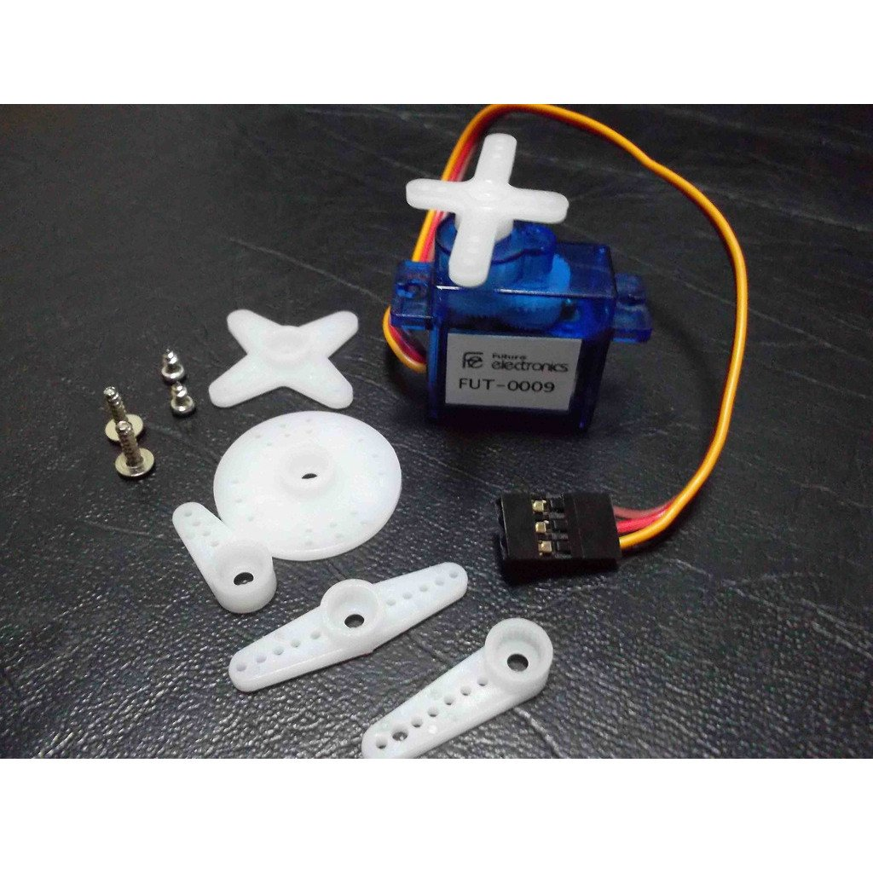

|  |  |
| --- | --- |
| **Operating voltage** | 4.2-6V |
| **Operating speed** | 0.12sec/60degree (4.8v),   0.10sec/60degree (6v) |
| **Stall Torque** | 1.3 kg.cm (4.8v), 1.3 kg.cm (6v) |
| **Dimension** | 22.3 x11.8x26.3 mm |
| **Weight** | 9g |
| **Kit includes** | Set of 6 pieces of arm servo horn with different sizes and shapes - horn mounting screws, servo mounting screws |

2- **DC Geared Motors for Robots (90 Degree Shaft**

# dc_motor_90_degree_shaft.jpg

• Voltage: 3V DC• No Load Speed: 65 +/- 10rpm • No Load Current: 125mA (max.170mA)• Minimum Torque: 800 gm.cm

# Wheels : 1- Robot Wheels (Tire) with Coupler robot_tire_with_coupler.jpg

**Outer diameter of wheel:** 65mm

**Width:** 28mm

**Brass coupler inner diameter:** 4mm

# 2- Robot Tire (Wheel) robot_wheels.jpg

**Outer dia of wheel:**         65mm

**Width:**                              28mm

**Internal Axe Diamter**:     3.7x5.3mm

**External Axe Diameter:**    13.8mm

# Ultrasonic Sensors 1-Ultrasonic Sensor (Range Finder) ultrasonic-sensor-_range-finder_-256px-256px_large_bf534964-592a-450d-8f40-71321bdbbba4.jpg

* Distance (Range): 2cm - 500cm
* Working Voltage : 5V(DC)
* Working Current : max 15 ma
* Working frequency : 40HZ
* Output Signal : 0-5V (Output high when obstacle in range)
* Sensor Angle : max 15 degree
* Accuracy : 0.3cm

# 2- Ultrasonic Sensor Module ultrasonic_module_large_8fef667d-dfc2-4f0b-875d-896a68bd12a0 (1).jpg

* Power supply: 5V DC
* Quiescent current: <2mA
* Effectual angle: <15°
* Ranging distance: 2cm – 400 cm
* Resolution: 1 cm
* Ultrasonic Frequency: 40k Hz

**Microcontroller :  
1- Raspberry Pi 3  
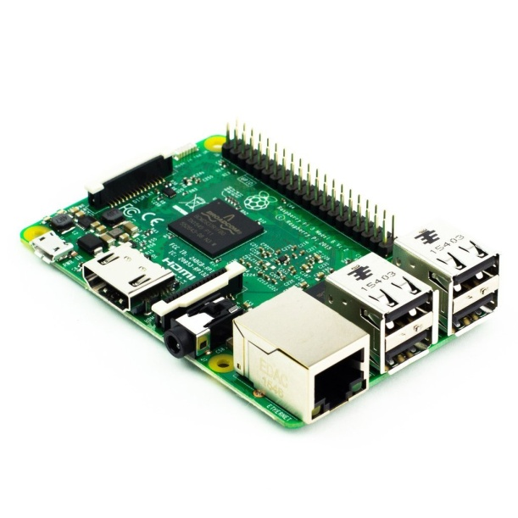** 1- Raspberry Pi 3 has built in (on board) WiFi and Bluetooth (low power or BLE).

2- The Raspberry Pi 3 new next generation processor with a speed of 1.2 Ghz is much faster than        [Rapberry Pi 2](http://store.fut-electronics.com/products/raspberry-pi-2-model-b" \t "_blank)with a speed of 900 Mhz.

The Pi 3 keeps the same shape, connectors, and mounting holes as the Pi 2. 40-pin GPIO header on the Pi gives you access to 27 GPIO, UART, I2C, SPI as well as 3.3 and 5V sources. Each pin on the GPIO header is identical to its predecessor the Pi 2. It still can run using  Linux or Windows 10 (free-of-charge) operating systems

# 2- ATmega16-16PU Atmel ATMEGA16_16PU_Atmel.jpg

**Brand:**                                                  Atmel

**Type:**                                                   ATmega16-16PU

**Data Bus Width:**                                   8 bit

**Maximum Clock Frequency:**              16Mhz

**Program Memory Size:**                         16KB

**Data RAM Size:**                                     1KB

**On-Chip ADC:**                                      Yes

**Operating Supply Voltage:**                  4.5 to 5.5 v

**Maximum Operating Temperature:**     85 C

**Package / Case:**                                    PDIP-40

**Mounting Style:**                                   Through Hole

**Data ROM Size:**                                    512 B

**Interface Type:**                                    JTAG, SPI, UART

**Number of Programmable I/Os:**          32

**Number of Timers:**                              3

**Bluetooth Module   
1-ESP32 Development Board (WIFI - Bluetooth)  
 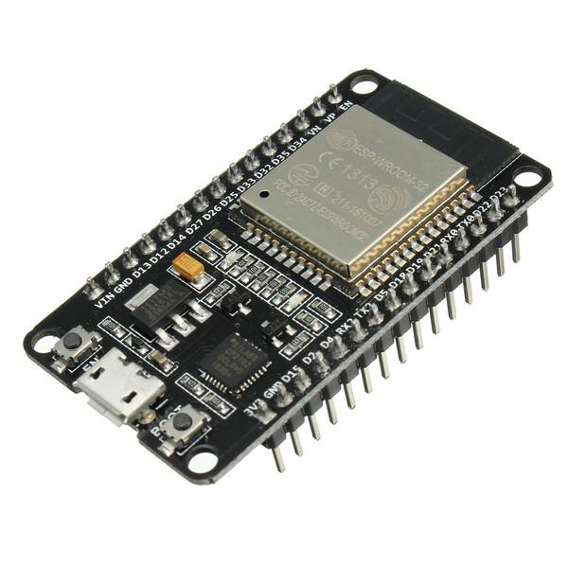**This is the ESP32 development board  with the incredible module ESP32  from [Espressif](http://espressif.com/). This is very powerful module which exceds by far the previous famous module ESP8266. The ESP32 has both WIFI and Bluetooth 4 capabilities (BLE). It also have 32 bit double core CPU, one dedicated for the wireless (WIFI & Bluetooth) and the other dedicated for the logic and control. The ESP32 also have 36 PIN for  your project as follows:

* **Analog-to-Digital Converter (ADC**) – Up to 16 channels of 12-bit SAR ADC’s. The ADC range can be set, in firmware, to either 0-1V, 0-1.4V, 0-2V, or 0-4V – no more weird 0-1V ADC.
* **Digital-to-Analog Converter (DAC)** – Two 8-bit DAC’s to produce true analog voltages
* **Pulse-Width Modulation (PWM)** – Up to 16 channels of PWM-capable pins for dimming LEDs or controlling motors.
* **Touch Sensor** – 10 GPIOs feature capacitive sensing; make a 10-key buttonpad.
* **UART** - Two UART interfaces, one is used to load code serially. They feature flow control, and support IrDA too.
* **I2C, SPI, I2S**– There are two I2C and four SPI interfaces to hook up all sorts of sensors and peripherals, plus two I2S interfaces if you want to add sound to your project.

# 2- Serial Bluetooth Module (Master/Slave) ATMEGA16_16PU_Atmel.jpg

This serial bluetooth module can work as either **master or slave.** This module also includes the base board, not only the core board, most functions are pre-set, so only the serial port communication is available but it’s more easy to use. It can be used also with arduino or Microcontroller.

**Features**

* Use CSR popular buletooth chip, bluetooth V2.0 Protocol standard.
* Serial port operation voltage 3.3V
* Baud rate set at 9600, but you can change it with AT command
* Operation current, pairing at 30MA, after pairing is 8 MA during communication
* Widely use for wireless data communication such as GPS navigation device, remote data collection, PDA devices
* Also can pair and communicate with laptop, laptop bluetooth adapter, PDA devices, Arduino
* Be aware default setting of the product is slave mode, communication only available between master and slave mode, but not master and master, or slave and slave mode.

# Transceiver

**2.4GHz Transceiver nRF 24L01 (2DB Antenna)  
  
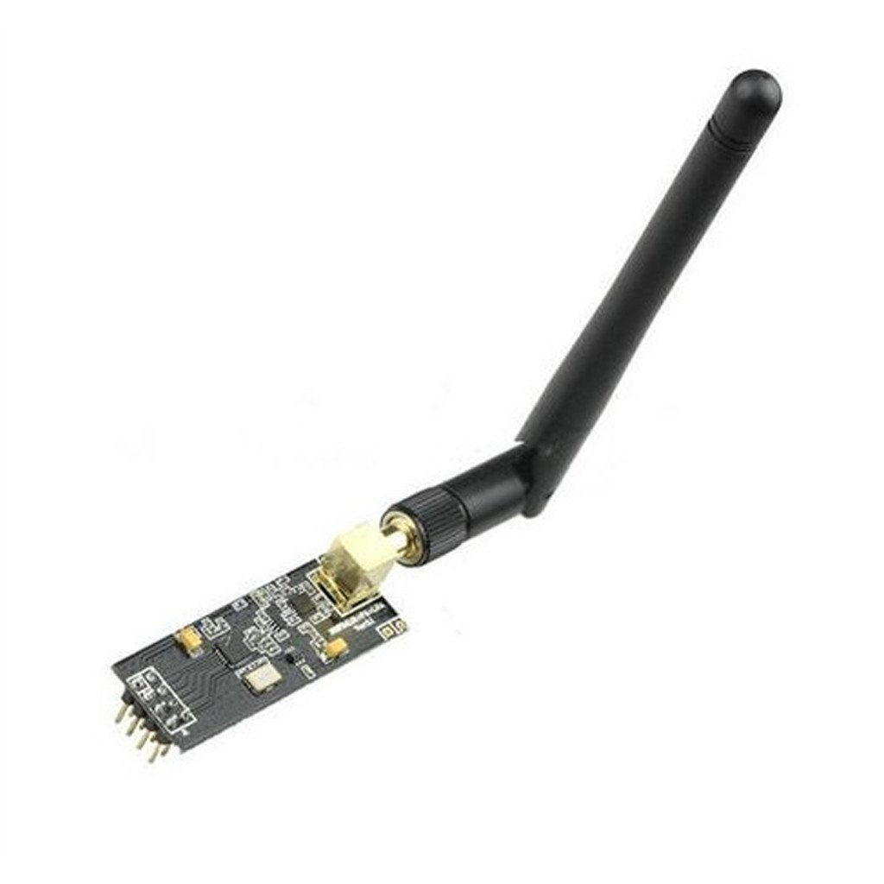**The latest version of 2.4 Ghz wireless transceiver based on Nordic nRF 24L01. This module is equipped with power amplifier (PA) and low noise amplifier (LNA) together with 2DB antenna. This increase the  transmission distance to reach 1000 meter at 250kbps data ratewith line of sight but at he same tie noise is decreased due to LNA.

The Nordic nRF24L01 integrates a complete 2.4GHz RF transceiver, RF synthesizer, and  Enhanced ShockBurst™ hardware protocol accelerator supporting a high-speed SPI interface for the application controller.

Transceivers like these both send and receive data in 'packets' of several bytes at a time. There is built-in error correction and resending, and it is possible to have one unit communicate with up to 6 other similar units at the same time.

**Features**

* Power Supply: 1.9 : 3.3 v
* 2DB Antenna
* Low noise amplifier (LNA) for noise supression
* Power Amplifier (PA)
* 1Km Range with line of sight at 250kbps
* Ultra low power consumption – months to years of battery lifetime
* 250kbps to 2Mbit Data Rate
* Auto Acknowledge & Auto Re-Transmit
* Multiceiver - 6 Data Pipes
* Software selectable channel from 2400MHz to 2525MHz (125 Selectable channels)

# 2- 2.4GHz Wireless Transceiver nRF 24L01 (85 meter)

**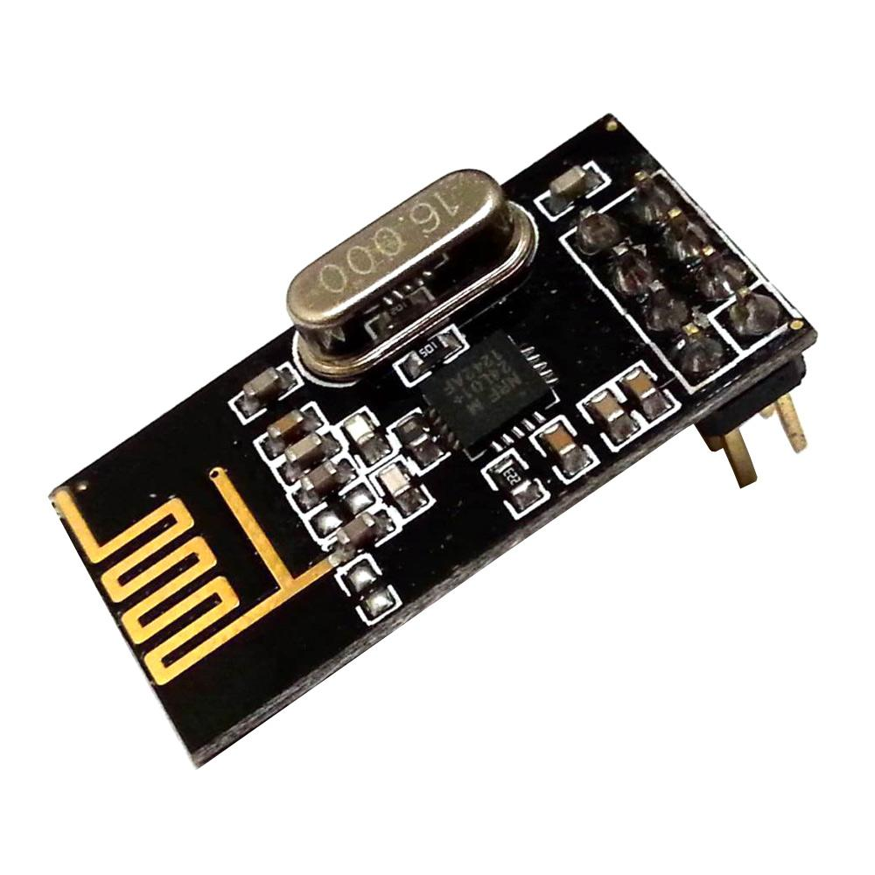**These are a series of 2.4 GHz Radio modules that are all based on the Nordic Semiconductor  module nRF24L01. The Nordic nRF 24L01 integrates a complete 2.4GHz RF transceiver, RF synthesizer, and  Enhanced ShockBurst™ hardware protocol accelerator supporting a high-speed SPI interface for the application controller.

The low-power module with range about (60 meter or so)Transceiver is available on a board with Arduino interface and built-in Antenna. Having two or more Arduinos be able to communicate with each other wirelessly over a distance opens lots of possibilities:

* Remote sensors for temperature, pressure, alarms, much more
* Robot control and monitoring up to 85 meters
* Remote control and monitoring of nearby or neighborhood buildings

Transceivers like these both send and receive data in 'packets' of several bytes at a time. There is built-in error correction and resending, and it is possible to have one unit communicate with up to 6 other similar units at the same time.

**Note:** We have tested this module in Future Electronics (Arduino Egypt) site with one tranceiver indoors and the other one outdoors and the communication distance was more than **85 meters**

**Features**

* Power Supply: 3.3 v
* On-board integrated pcb antenna
* 100m Range at 250kbps
* Ultra low power consumption – months to years of battery lifetime
* 250kbps to 2Mbit Data Rate
* Auto Acknowledge & Auto Re-Transmit
* Multiceiver - 6 Data Pipes
* Software selectable channel from 2400MHz to 2525MHz (125 Selectable channels)